**1. [Screen Shot, Answer - Explanation] df is a command that displays the amount of disk space**

**available on the file system containing each file name argument. Read man page of df command.**

**Run the command df to find out how many disk blocks are available and how many are in use. Does**

**the sum of these equals the total number of disk blocks on the disk? If not, explain why there is a**

**difference.**

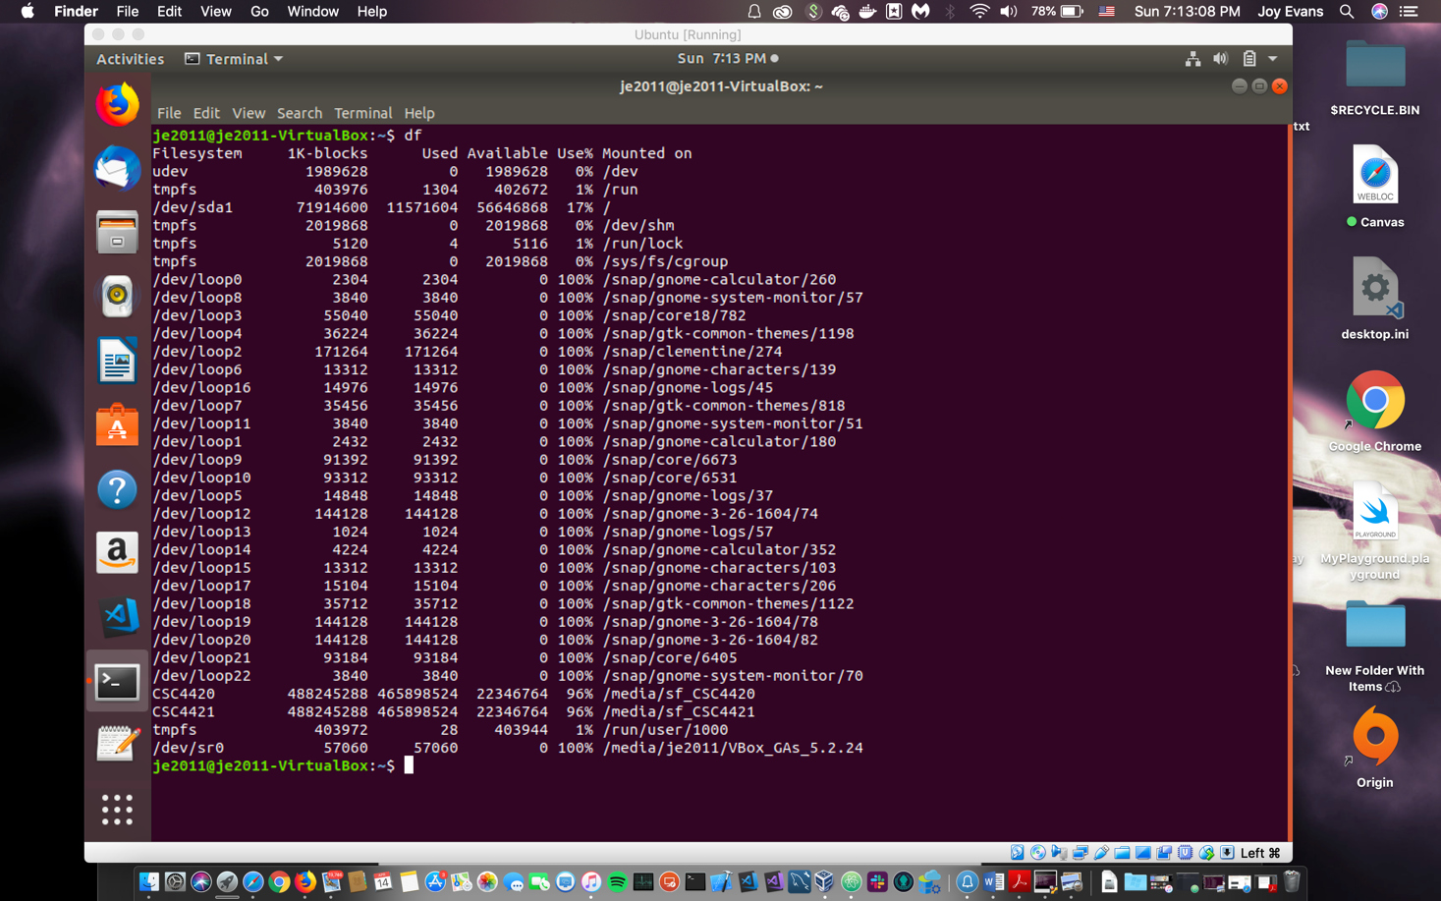

﻿/dev/sda1 71914600 11571604 56646868 17% /

Used: 11571604

Available: 56646868

11571604 + 56646868 = 68218472 or about 68 GB. The disk for this virtual machine has about 73 GB stored for Linux. 73 - 68 = 5 GB. Generally memory is set aside and reserved for a new system upon creation for the root and system functionality and processes.

**2. Next run the command df -i to find out how many nodes are available and in use. [Screen Shot]**



**3. Now create a new file with just a few characters in it, and again run df and df -i commands. [Screen**

**Shot x2]**

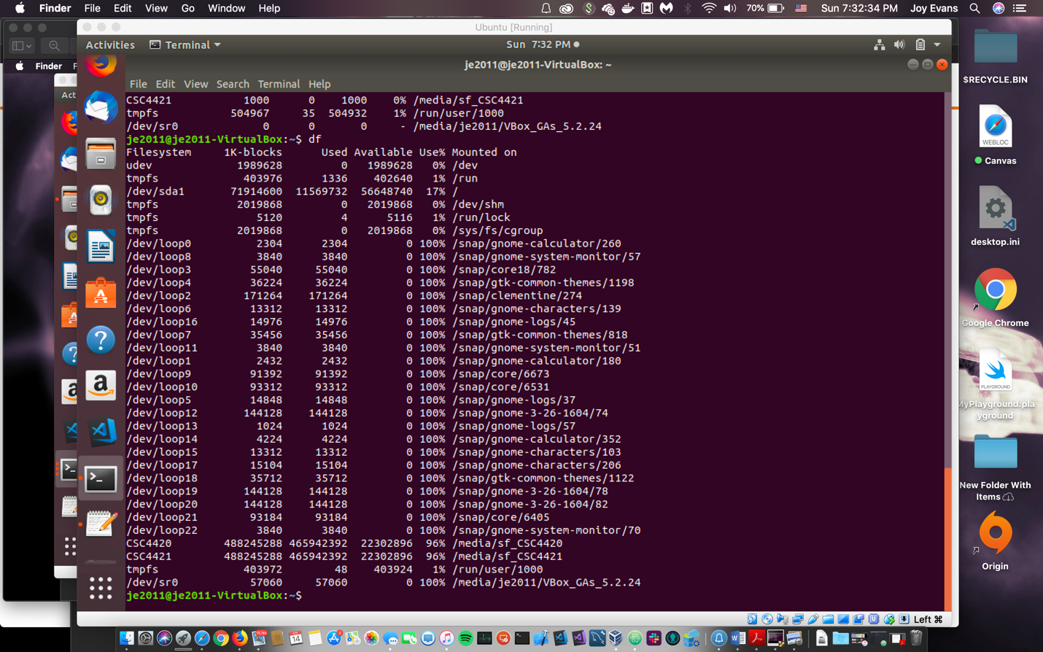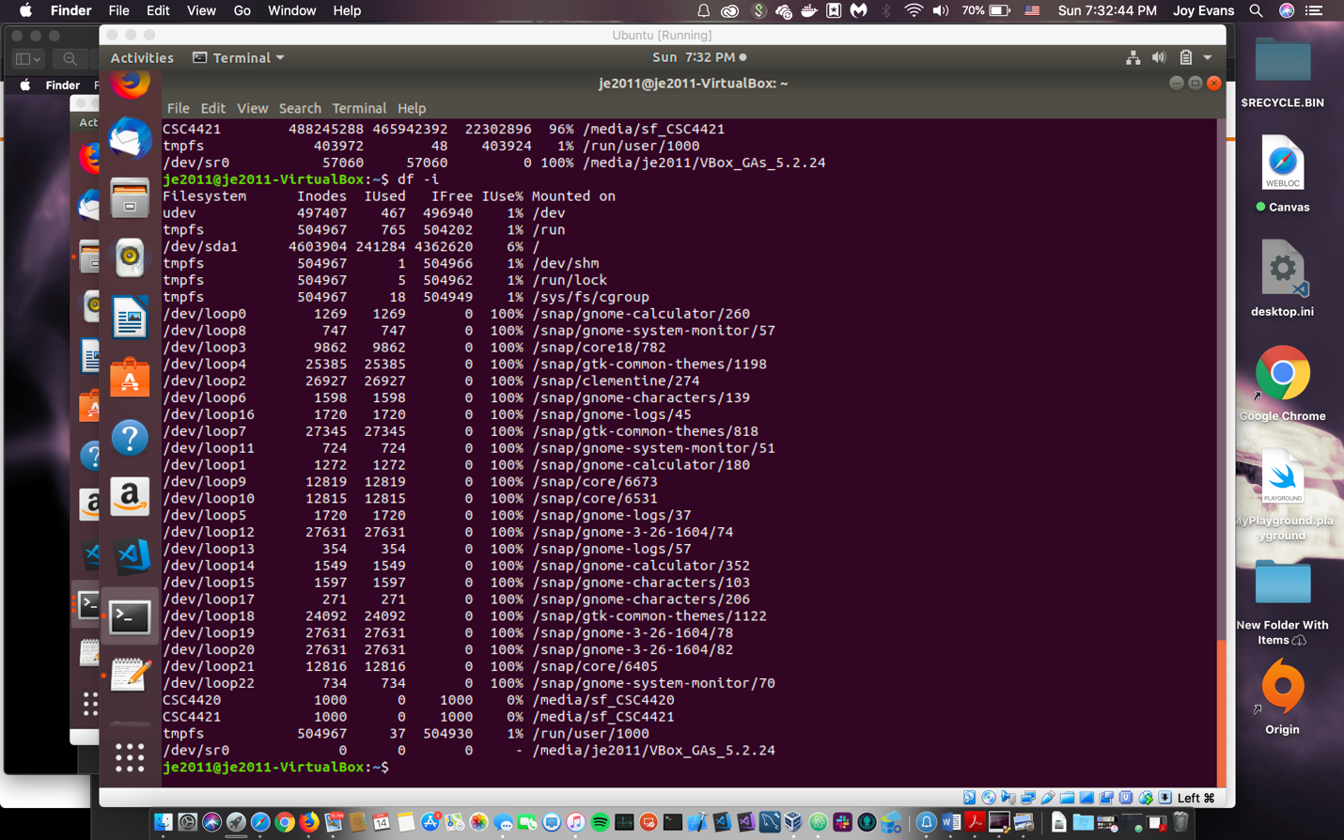

**4. Explain the effect of creating this new file. [Answer - Explanation]**

﻿

/dev/sda1 71914600 11569732 56648740 17% /

Used: 11569732

Available: 56648740

11569732 + 56648740 = 68218472

The available memory went down by 1872. The small text file has a of 32 bytes. The total of used and available memory is the same.

**5. Now increase the size of this new file by entering a large number (> 5000) of characters, and again run**

**df and df i commands. Do you notice a difference? [Screen Shot x2, Answer - Explanation]**

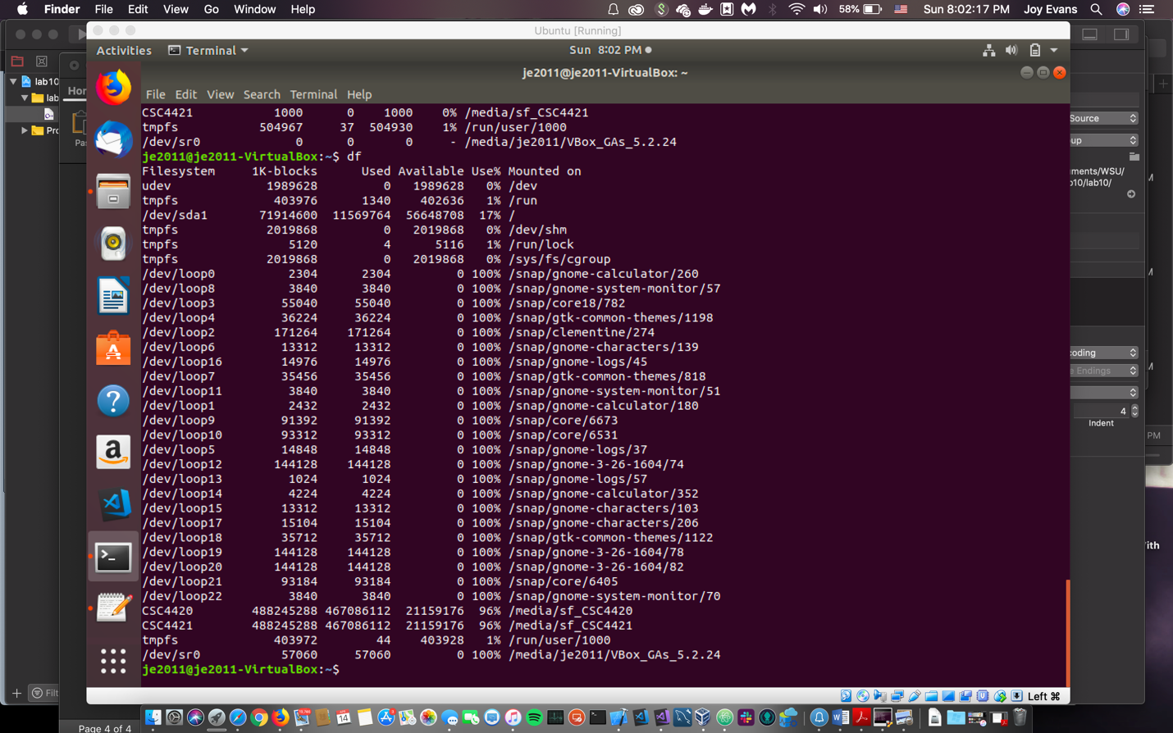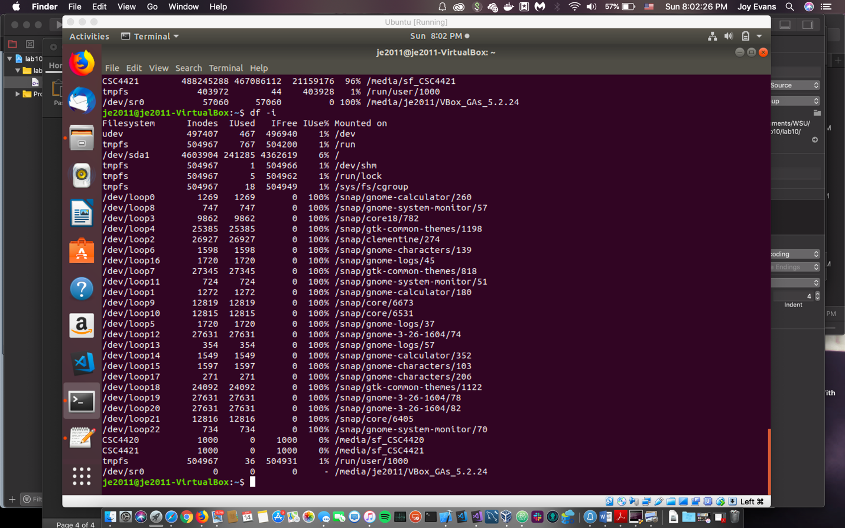

﻿/dev/sda1 71914600 11569764 56648708 17% /

Used: 11569764

Available: 56648708

56648740(from previous step) - **56648708** = 32

The file size is now 5.0 kB and there is now 32 bytes of less memory than before.

**6. Repeat the last step, this time entering (> 50; 000) characters. [Screen Shot x2, Answer - Expla-**

**nation]**

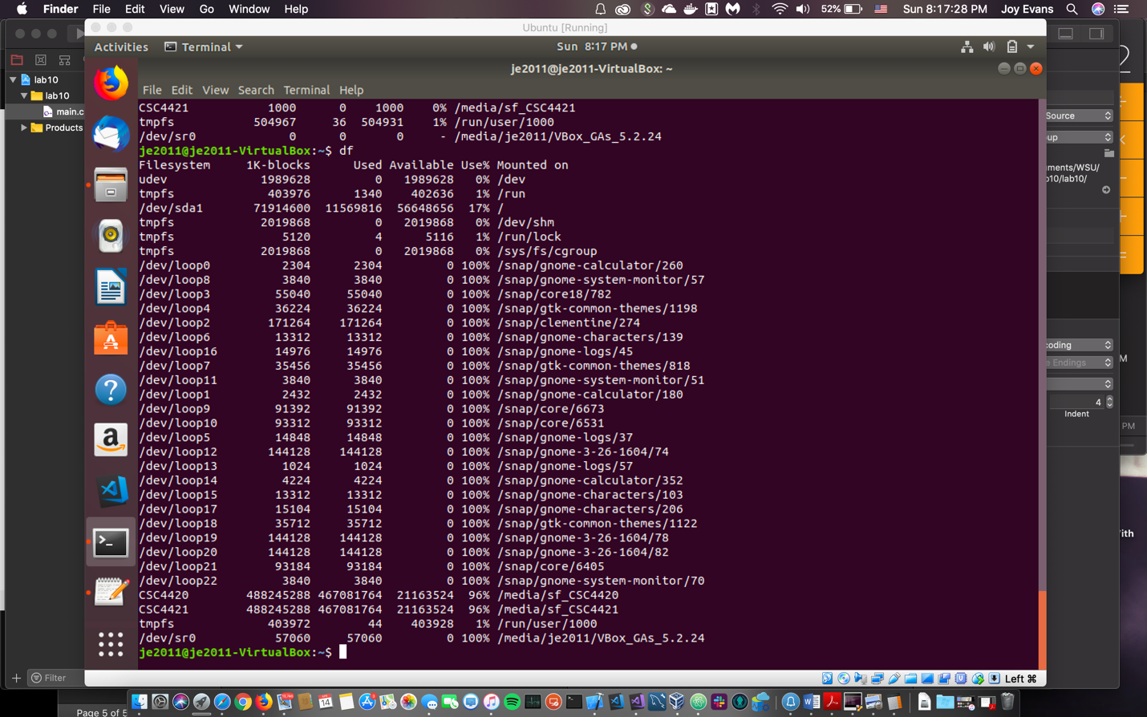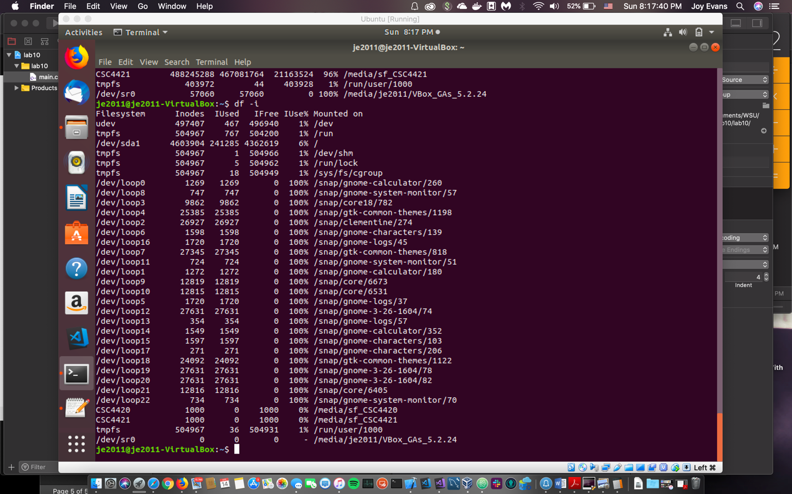

**﻿/dev/sda1 71914600 11569816 56648656 17% /**

The file size has now multiplied by 10 and is now 50 kB.

56648708 - **56648656 =** 52. The available memory now differs by 52 bytes.

**7. Repeat the last step, this time entering (> 500; 000) characters. [Screen Shot x2, Answer - Ex-**

**planation]**

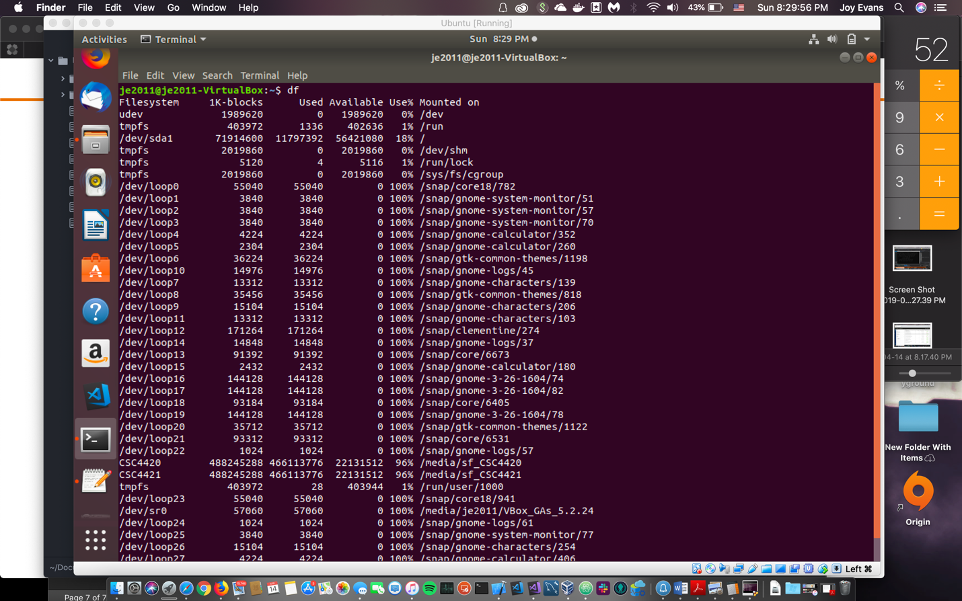

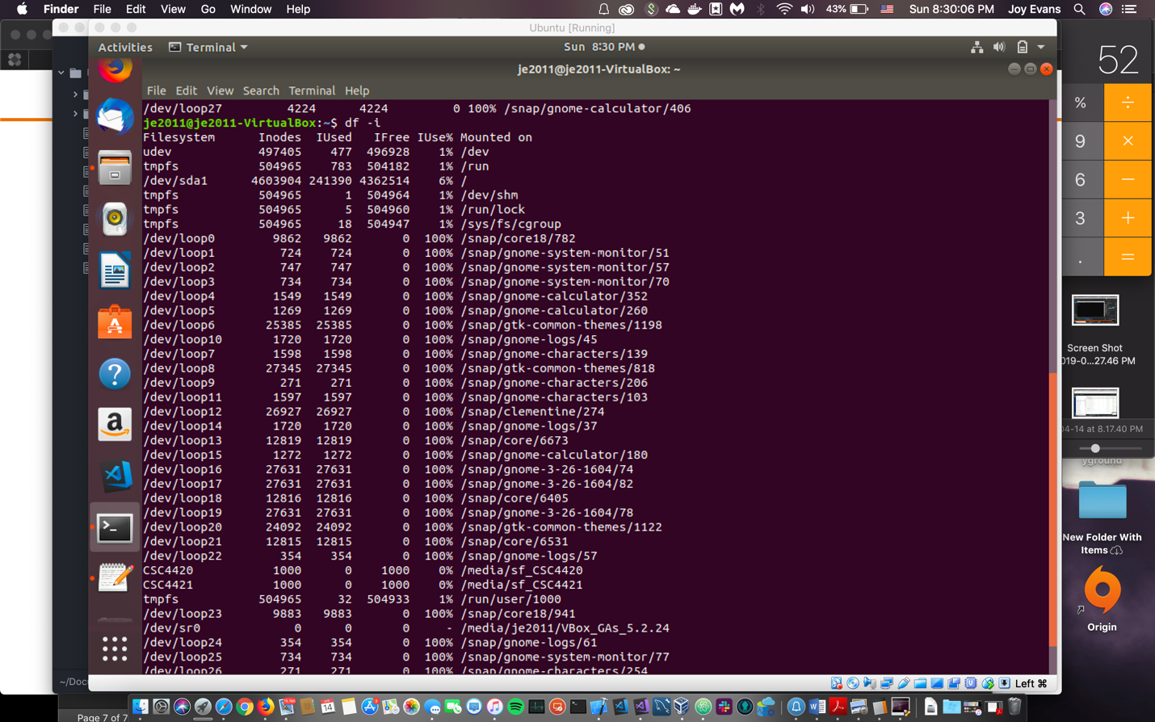

**﻿/dev/sda1 71914600 11797392 56421080 18% /**

56648656 **-56421080 =** 227,576

My virtual machine unexpectedly crashed while performing this task so I am unsure if this had some effect on the change in memory. However, the file size for the text file is now 319.5 kb and available memory now differs by 227,576.

**8. Explain the effect of increasing the size of the new file. [Answer - Explanation]**

The change in file size obviously increases the used memory and decrease available memory as the file increases as well.